ISEBTT Travel Grant Application – Sponsored by Frontiers

Frontiers is generously sponsoring travel grants for both graduate students and post-doctoral researchers to attend the 4th World Congress on Electroporation (October 9-13, 2022), to be held in Copenhagen, Denmark. Frontiers wishes to support young researchers working in the field of Biotechnology and Bioengineering focusing on, but not limited to, electroporation, nanosecond pulsed electric fields, electrochemotherapy and irreversible electroporation.

To apply for the award, please complete the form below and provide all the requested documents. All application materials are to be sent via email to mc@cap-partner.eu by May 15, 2022. Awardees are selected by a Grant Award Committee and will receive a notification by June 1, 2022.

As a stipulation of funding, award recipients are expected to submit a brief 200 words report after the meeting summarizing their learning experience at the congress.

Name _________________________________________________________
University _________________________________________________________
Country _________________________________________________________
Name of Supervisor/Advisor _________________________________________________________
Email address _________________________________________________________
Please check one:
Postgraduate student
MSc study
PhD study – state the year of current PhD training.
Post-doc researcher

Abstract Title_________________________________________________________________________

Submission number______

Attachments:
- Copy of abstract submitted to the congress.
- Letter of support from Supervisor/Advisor, confirming student or post-doc status.
- CV

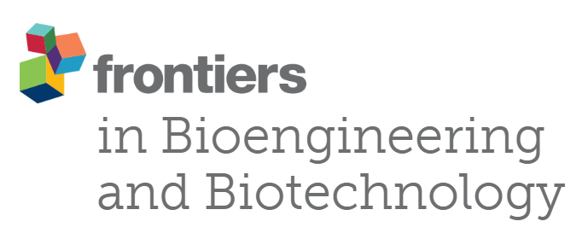

Frontiers has no influence on the selection process, which is managed solely by the 4th World Electroporation Congress Grant Award Committee.

